CNNP- Skill 1

Name: P. Havishaa Reddy
Roll no: 2520030371
Section: 7

Encapsulation Builder: Analyze the overhead introduced by protocol headers and determine how encapsulation affects network efficiency.
Aim: To capture network packets and understand how Ethernet, IP, and TCP/UDP headers are added during data transmission.

Step 1: Install Wireshark

Step 2: Select your network interface

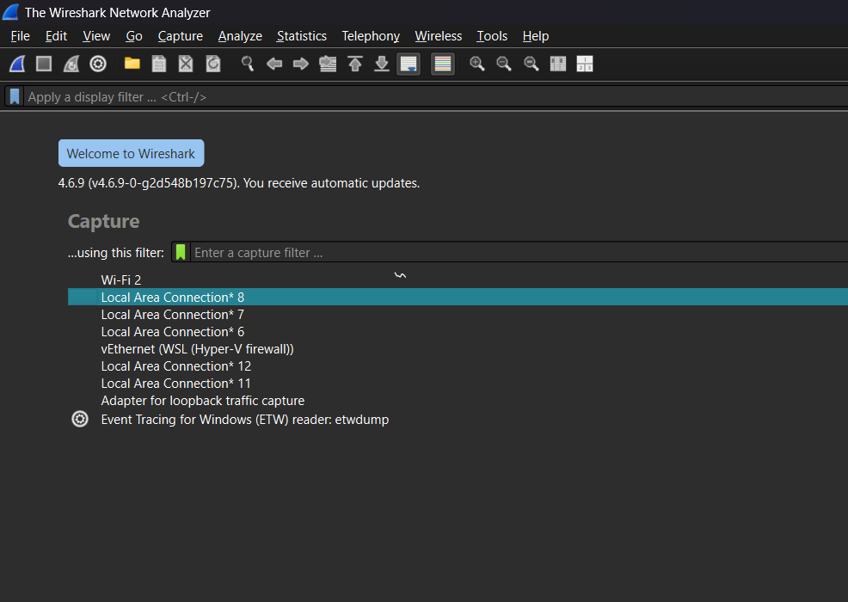

Step 3: Generate network traffic

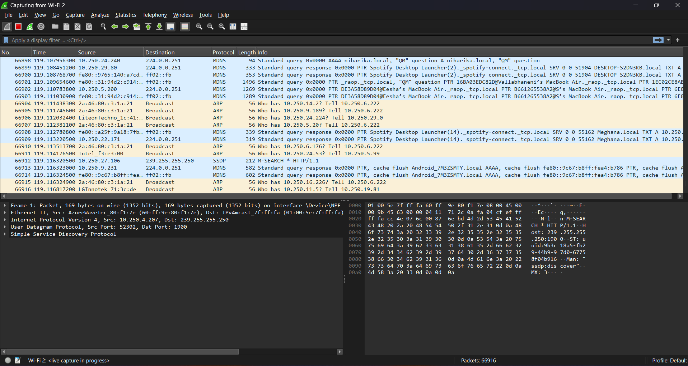

Step 4: Apply display filters
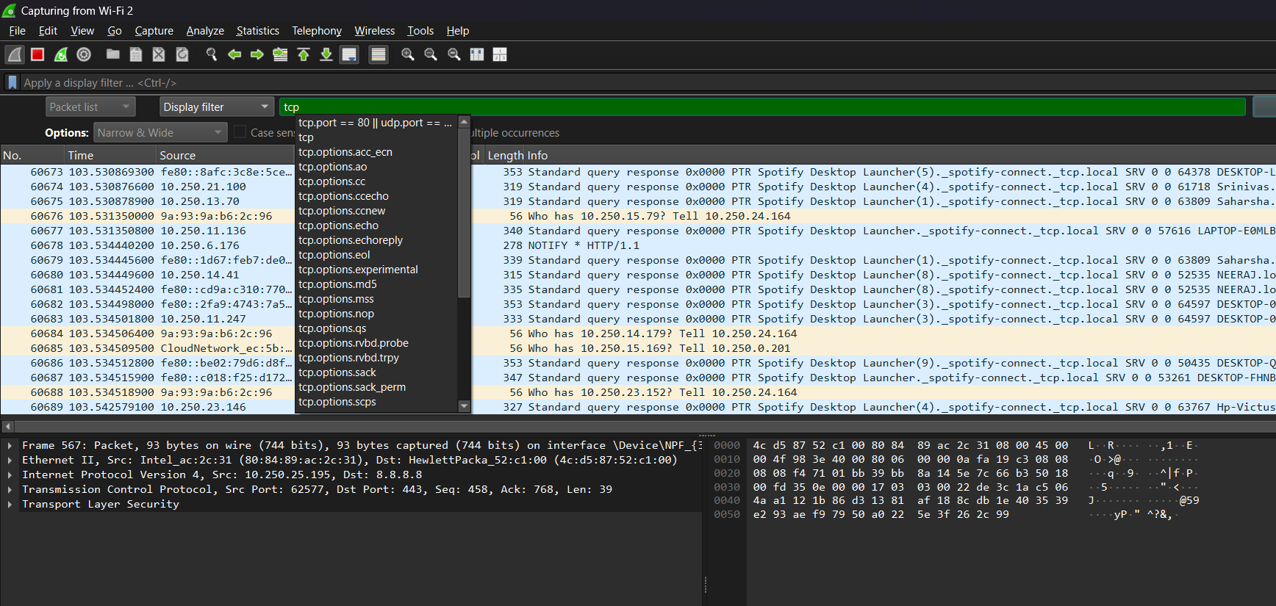

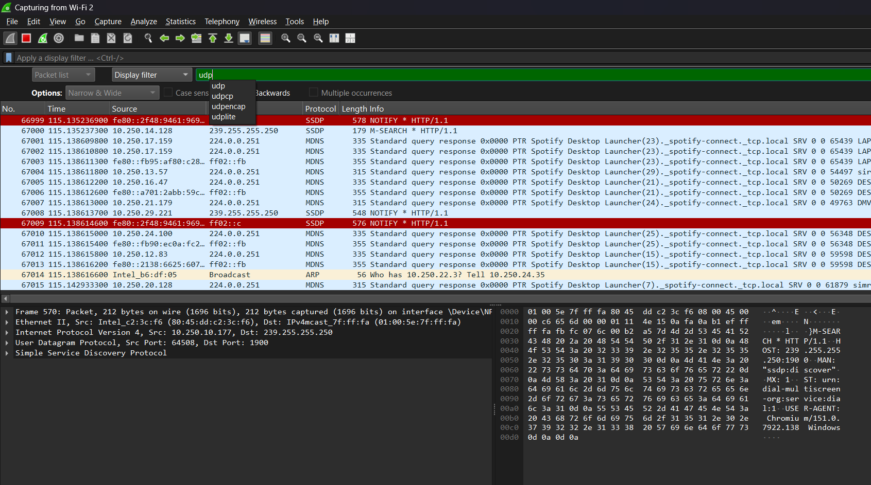

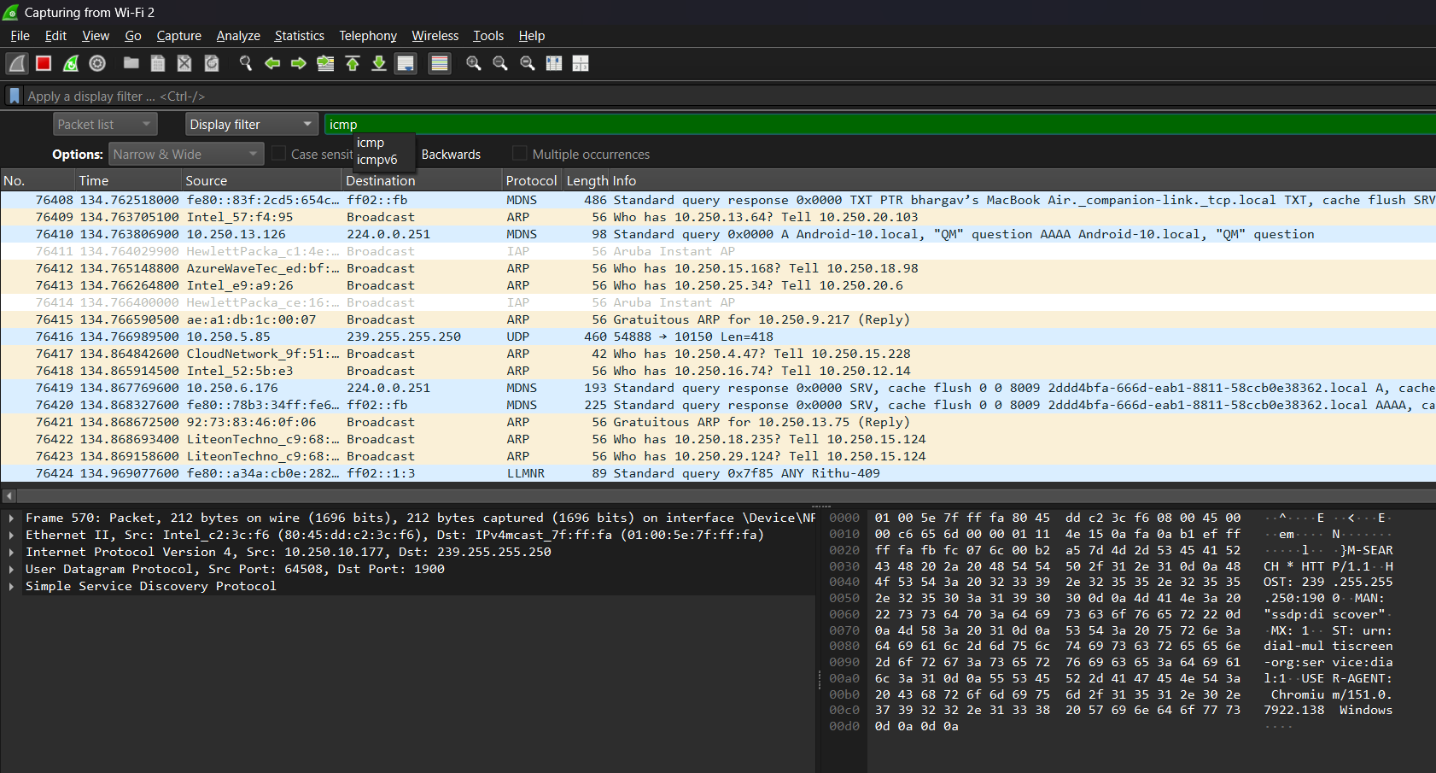

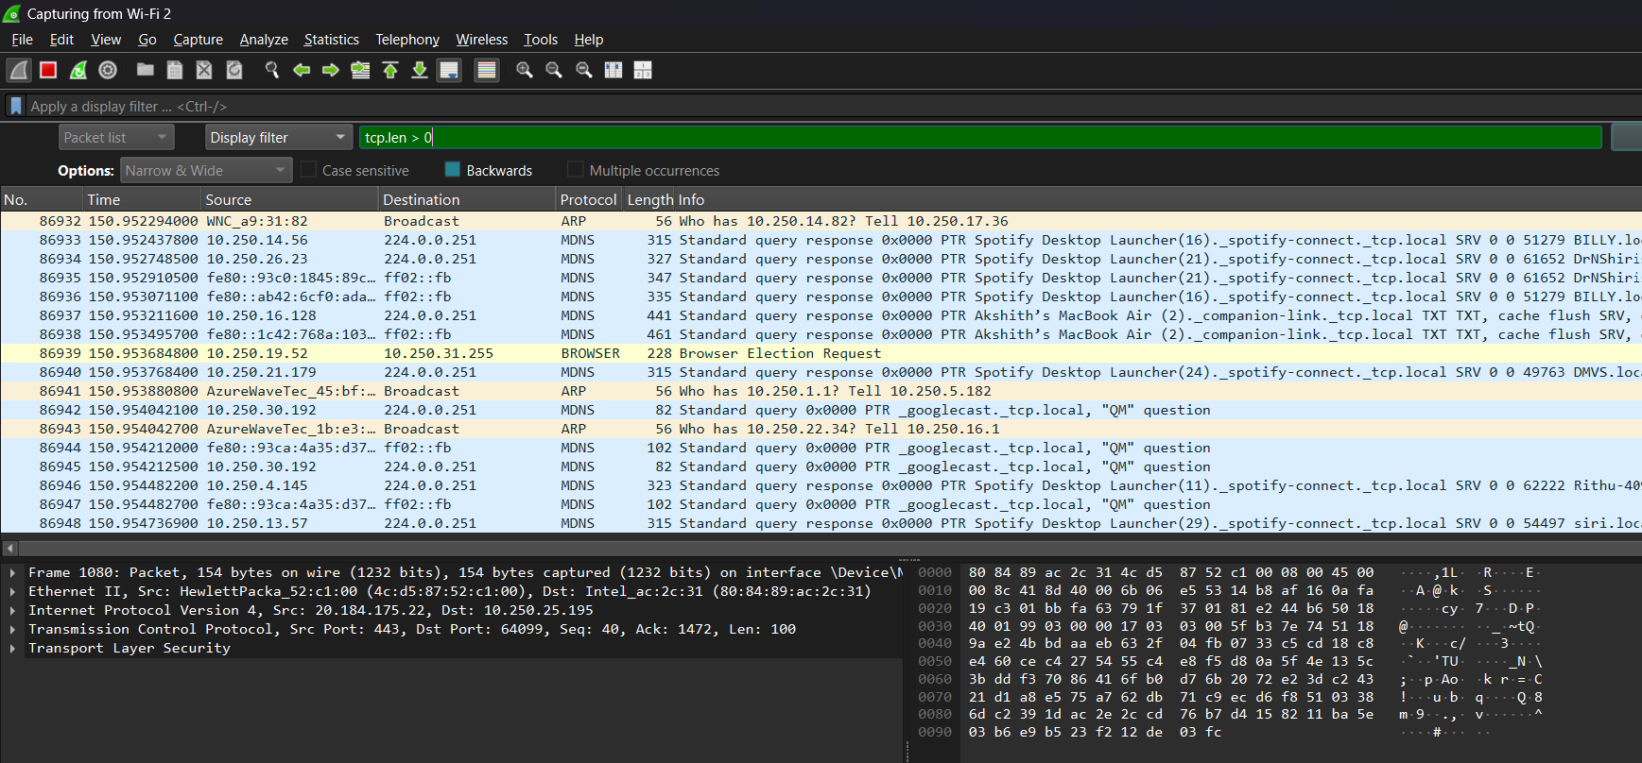

Step 5: Inspect packet headers

tcp:
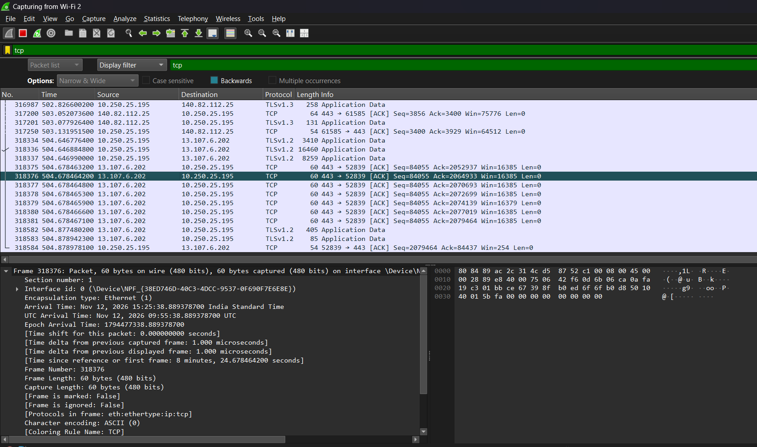

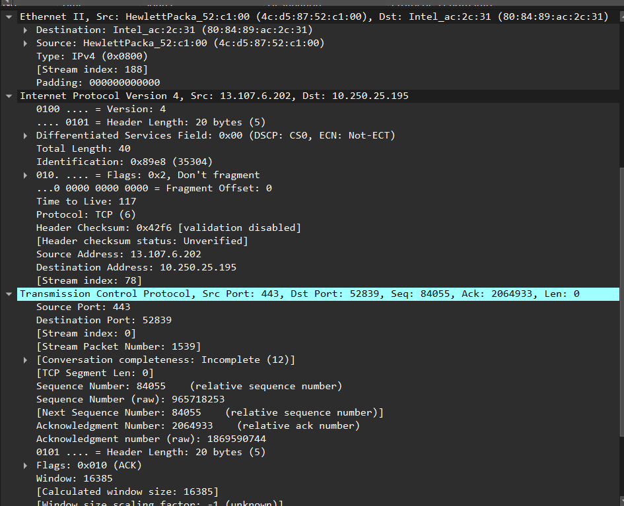

udp:
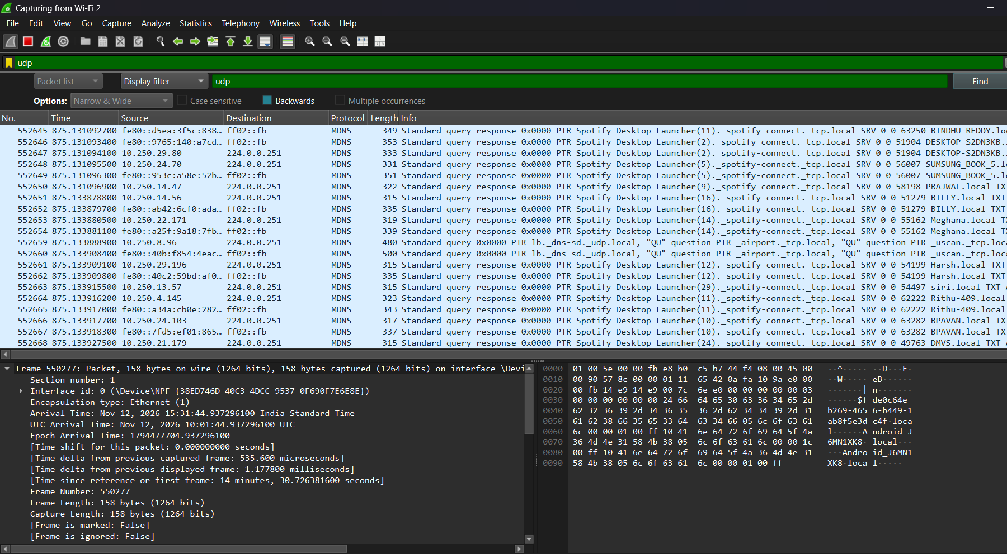

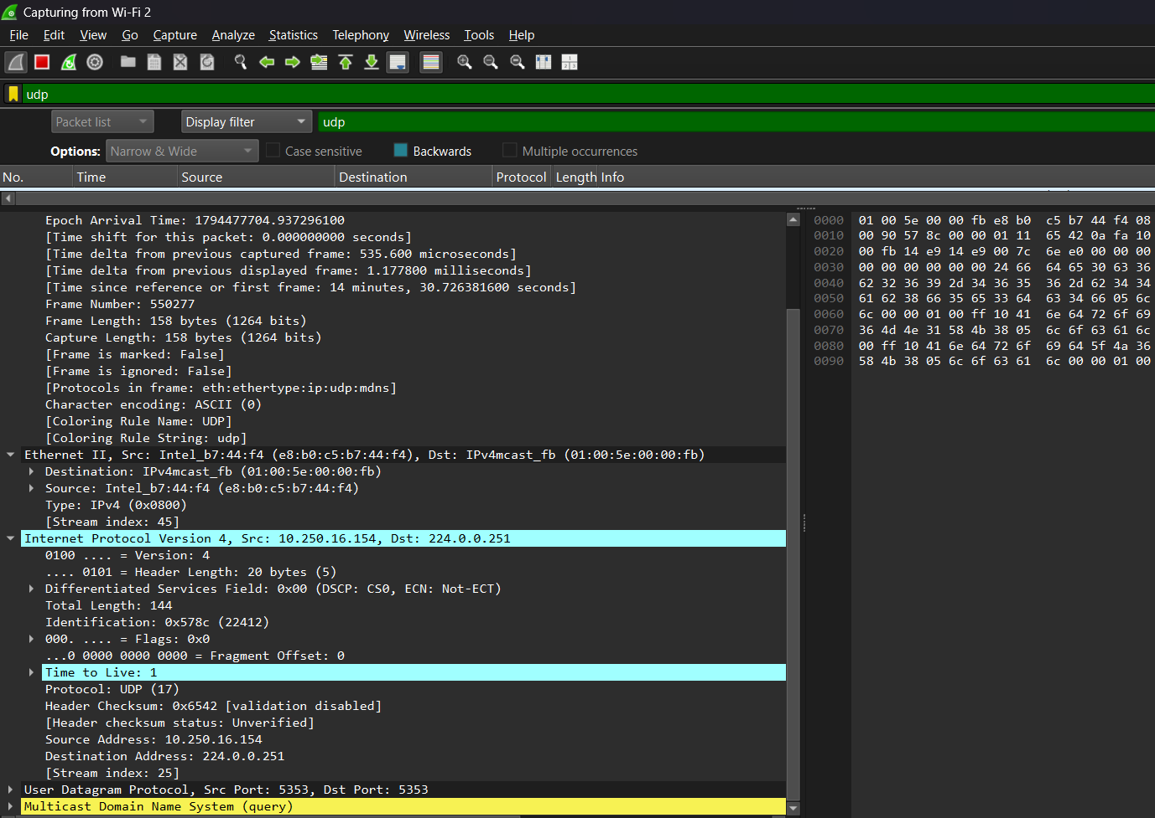

Step 6: Calculate header overhead

TCP Packet Observation:
A TCP packet was selected from the packet list. The Frame, Ethernet II,
Internet Protocol Version 4, and Transmission Control Protocol sections
were expanded and inspected.

Frame Length = 60 bytes
Source MAC Address = 4c:d5:87:52:c1:00
Destination MAC Address = 80:84:89:ac:2c:31
IPv4 Header Length = 20 bytes
IPv4 Total Length = 40 bytes
TCP Header Length = 20 bytes
TCP Segment Length = 0 bytes

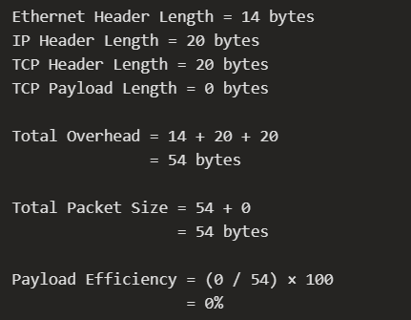

UDP Packet Observation:
A UDP packet was selected from the packet list and inspected in Wireshark.
The Ethernet II, IPv4, and UDP headers were examined.

Frame Length = 158 bytes
Ethernet Header Length = 14 bytes
Source MAC Address = e8:b0:c5:b7:44:f4
Destination MAC Address = 01:00:5e:00:00:fb
IP Header Length = 20 bytes
IP Total Length = 144 bytes
UDP Header Length = 8 bytes
Payload Length = 116 bytes
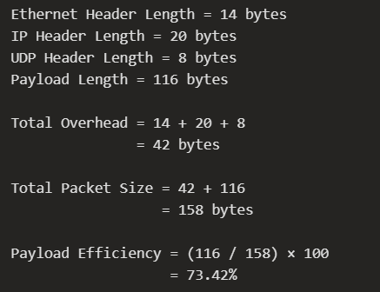

Step 7: Observation table


